Customer Shopping Behavior Analysis

1. Project Overview
This project analyzes customer shopping behavior using transactional data from 3,900 purchases across various product categories. The goal is to uncover insights into spending patterns, customer segments, product preferences, and subscription behavior to guide strategic business decisions.
2. Dataset Summary
- Rows: 3,900 - Columns: 18 - Key Features: - Customer demographics (Age, Gender, Location, Subscription Status) - Purchase details (Item Purchased, Category, Purchase Amount, Season, Size, Color) - Shopping behavior (Discount Applied, Promo Code Used, Previous Purchases, Frequency of Purchases, Review Rating, Shipping Type) - Missing Data: 37 values in Review Rating column
3. Exploratory Data Analysis using Python
We began with data preparation and cleaning in Python:
● Data Loading: Imported the dataset using pandas.
● Initial Exploration: Used df.info() to check structure and .describe() for summary statistics.
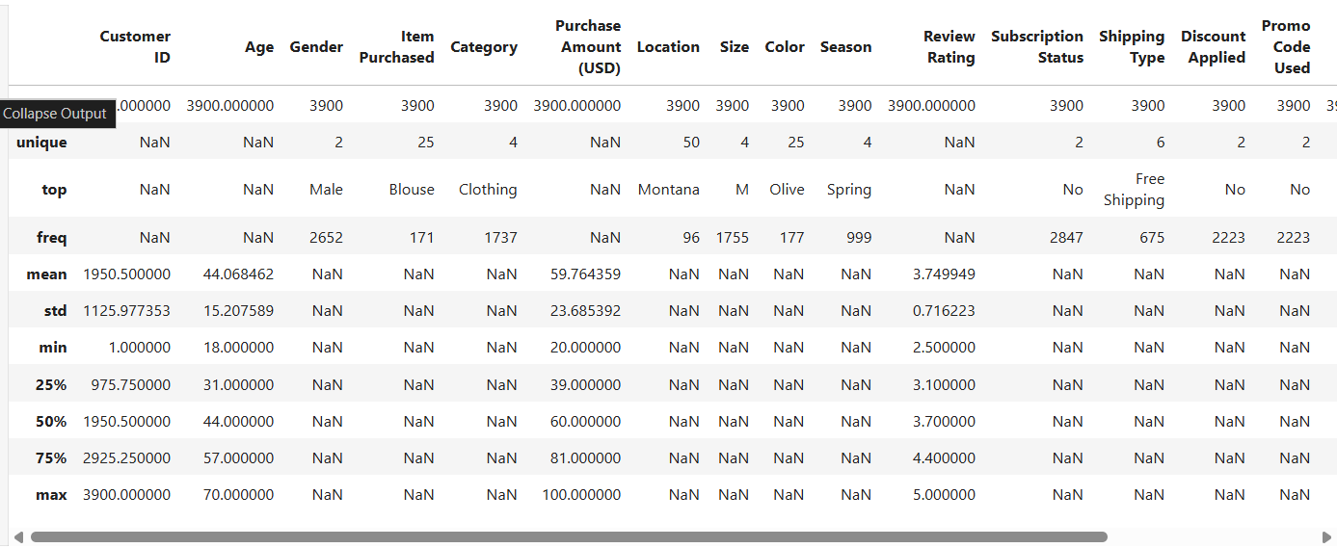

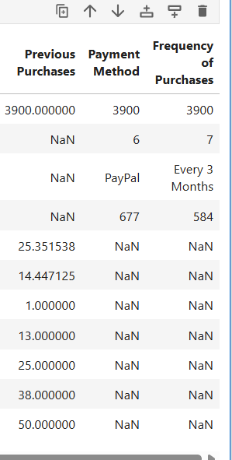

● Missing Data Handling: Checked for null values and imputed missing values in the Review Rating column using the median rating of each product category.
● Column Standardization: Renamed columns to snake case for better readability and documentation.
● Feature Engineering: ○ Created age_group column by binning customer ages.
○ Created purchase_frequency_days column from purchase data.

● Data Consistency Check: Verified if discount_applied and promo_code_used were redundant; dropped promo_code_used.
● Database Integration: Connected Python script to PostgreSQL and loaded the cleaned DataFrame into the database for SQL analysis.

4. Data Analysis using SQL (Business Transactions)
We performed structured analysis in PostgreSQL to answer key business questions:
- Revenue by Gender – Compared total revenue generated by male vs. female customers.
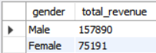

- High-Spending Discount Users – Identified customers who used discounts but still spent above the average purchase amount.
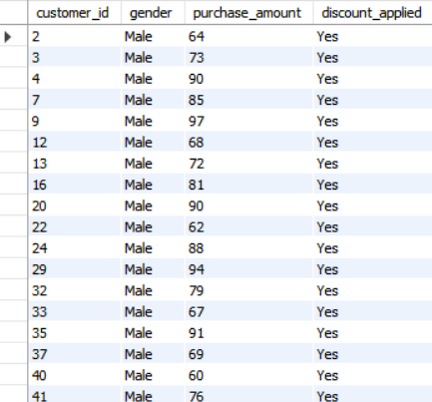

- 5 products with the highest average review rating: Found products with the highest average review ratings.

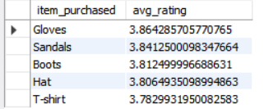

- Shipping Type Comparison – Compared average purchase amounts between Standard and Express shipping.

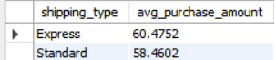

- Subscribers vs. Non-Subscribers – Compared average spend and total revenue across subscription status.
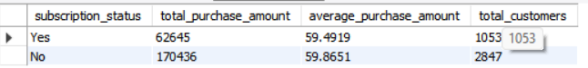

- Discount-Dependent Products – Identified 5 products with the highest percentage of discounted purchases.
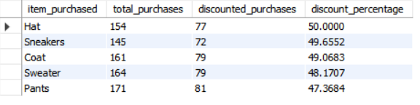

- Customer Segmentation – Classified customers into New, Returning, and Loyal segments based on purchase history.

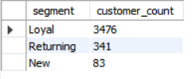
- Top 3 Products per Category – Listed the most purchased products within each category.
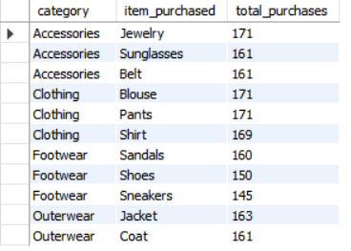

- Repeat Buyers & Subscriptions – Checked whether customers with >5 purchases are more likely to subscribe.
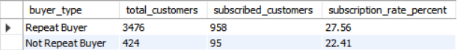

- Revenue by Age Group – Calculated total revenue contribution of each age group.

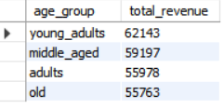
- Percentage revenue contribution by each group -- Calculated percentage revenue contribution of each age group.

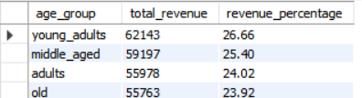

5. Dashboard in Power BI
Finally, we built an interactive dashboard in Power BI to present insights visually.
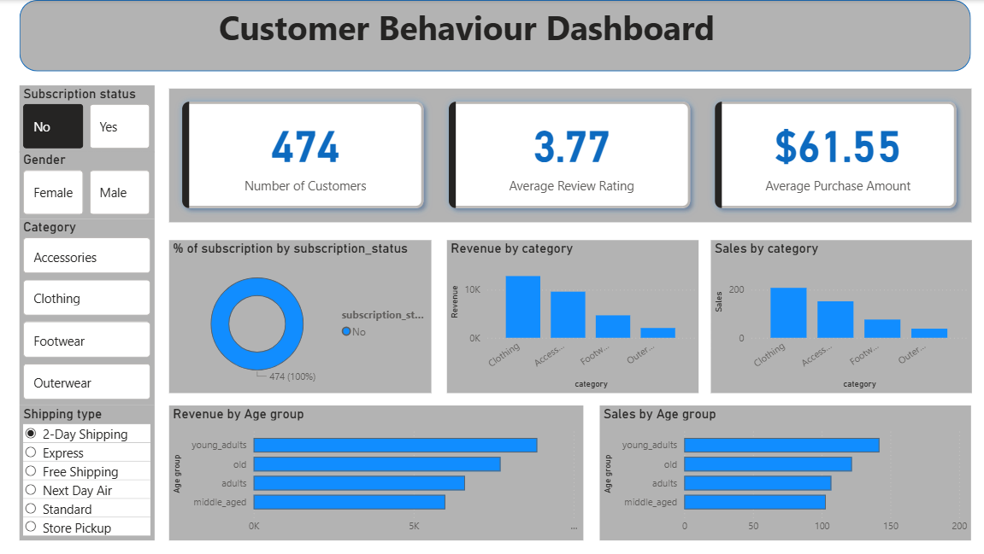

Business Summary
- Male customers generate almost double the revenue of female customers, making them the primary revenue driver.
- Discount usage is high, especially among male customers, and many discounted purchases still fall above the average purchase amount.
- Top-rated products include Gloves, Sandals, Boots, Hat, and T-shirts, making them strong performers in customer satisfaction.
- Express shipping users spend slightly more on average than Standard shipping users.
- Non-subscribers contribute more total revenue, but subscribers form a large customer base (1053 users).
- Certain products depend heavily on discounts (Hat, Sneakers, Coat, Sweater, Pants → ~47–50% discounted).
- Loyal customers dominate (3476 out of 3900), showing strong repeat behavior and retention potential.
- Top-selling products vary by category, indicating strong demand for Accessories, Clothing, Footwear, and Outerwear.
- Repeat buyers represent 3,476 customers and generate revenue at a higher rate than one-time buyers (27.56% vs. 22.41% in some metric).
- oung adults contribute the highest revenue (62,143) and highest revenue share (26.66%) among all age groups.
- Middle-aged (59,197 revenue) and adults (55,978 revenue) together make up nearly 50% of total revenue, indicating strong purchasing power.

Business Recommendations
1. Target Male Customers More Aggressively
- Run male-focused campaigns, upsell premium products, and tailor product bundles to this high-revenue segment.
2. Strengthen Subscription Program
- Add benefits (free express shipping, exclusive offers) to increase subscriber average order value and retention.
3. Reduce Discount Dependency on Certain Products
- Adjust pricing, improve product visuals, and introduce bundles for items with 50%+ discount reliance.
4. Leverage High-Rated and Top-Selling Products
- Feature Gloves, Sandals, Boots, etc. in ads, homepage banners, and recommendation systems to maximize conversions.
5. Use Customer Segmentation to Personalize Marketing
- Reward loyal customers with VIP perks, entice returning users with targeted offers, and attract new customers with welcome discounts.
6. Develop Targeted Strategies for Middle-Aged & Adult Segments
- Create segment-specific promotions, bundles, or subscription models that address the needs of these age groups (e.g., family-oriented deals, wellness products, or convenience-focused services). Use email marketing and retargeting ads to reinforce value and utility.

